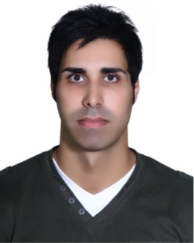 ***yasan forouzani***

***PERSONAL INFORMATION***

**Mobile:** 98-921-6247616

**Mobile:** 98-911-4582297

**Home:** 98-151-3255357

**Email:** yasan.f3@gmail.com

**Address:** behzisty st,molamajedin Ave.shohada sq,Sari, Iran

**Postal code**: 48177-33857

***SUMMARY***

***Sex:*** Male | ***Date*** ***of*** ***birth:*** 23/01/1987 | ***Nationality:*** Iranian

**Current** **Location**: Iran

**Current position:**  Employeable

**Preferred Locations:**  Anywhere in Iran, Anywhere outside Iran

**Salary expectation:** ----------

***JOB APPLIED FOR:*** *Civil Engineering*

***POSITION:*** *Supervisor; Head of Staff; head of projects*

***PREFERRED******JOB:*** *Dam construction; engineering projects; civil projects; petroleum-related projects*

***WORK EXPERIENCE***

*(2006 – 2008) & (2009 – 2011) ▪Supervision of on-going projects*

*▪Vice president*

***Business or sector:*** *Private sector*

***SKILLS***

**Communication skills:**  *▪Good communication skills*

*▪Teaching software*

**Organisational / managerial skills: ▪***Leader ship (head of the entire staff)*

*▪Job assignment*

*▪Management of the resources*

**Job-related skills: ▪**Construction design

**▪***Quality assessment*

**Computer skills: ▪***Word. Excel .Power point. Access,*

*ETabs, Safe, AutoCAD, MSP (attending the classes)*

**Other skills: ▪***Fixing electronic machines*

**▪***Driving*

***EDUCATION AND TRAINING***

*B.Sc. in Civil Engineering,* Azad University, Qaemshashr Branch

**list of principal subjects covered or skills acquired:**

* *Steel*
* *Concrete*
* *Earthquake*
* *Construction analysis*
* *Mathematics*
* *Concrete technology*

***LANGUAGES***

**Mother****tongue:** *Persian*

**Other language:**

|  |  |  |  |  |
| --- | --- | --- | --- | --- |
| *UNDERSTANDING* | | *SPEAKING* | | *WRITING* |
| *Listening* | *Reading* | *Spoken production* | *Spoken interaction* |  |
| *Good* | *Good* | *Good* | *Good* | *Good* |
| *Top Notch English Series, Level 3 (Pre-Advanced)* | | | | |

*English*

***COMMENTS***

*I need this job very immediately and I'll be able to handle hard job and difficult conditions in Iran and other countries (on land and on sea)*